**Polygonal Transformations** DATE: ________

*Target 4B. Describe and illustrate how a rectangle and isosceles trapezoid are mapped onto themselves using transformation.*

*Target 4C. Determine lines of reflection/symmetry and degrees of rotational symmetry in regular polygons.*

**Vocabulary**

**Translation:** a transformation of the plane that slides every point of a figure the same distance in the same direction. ( x, y ) 🡪 ( x + #, y + # )

**Reflection:**  like a mirror, an object is flipped over a given line or axis.

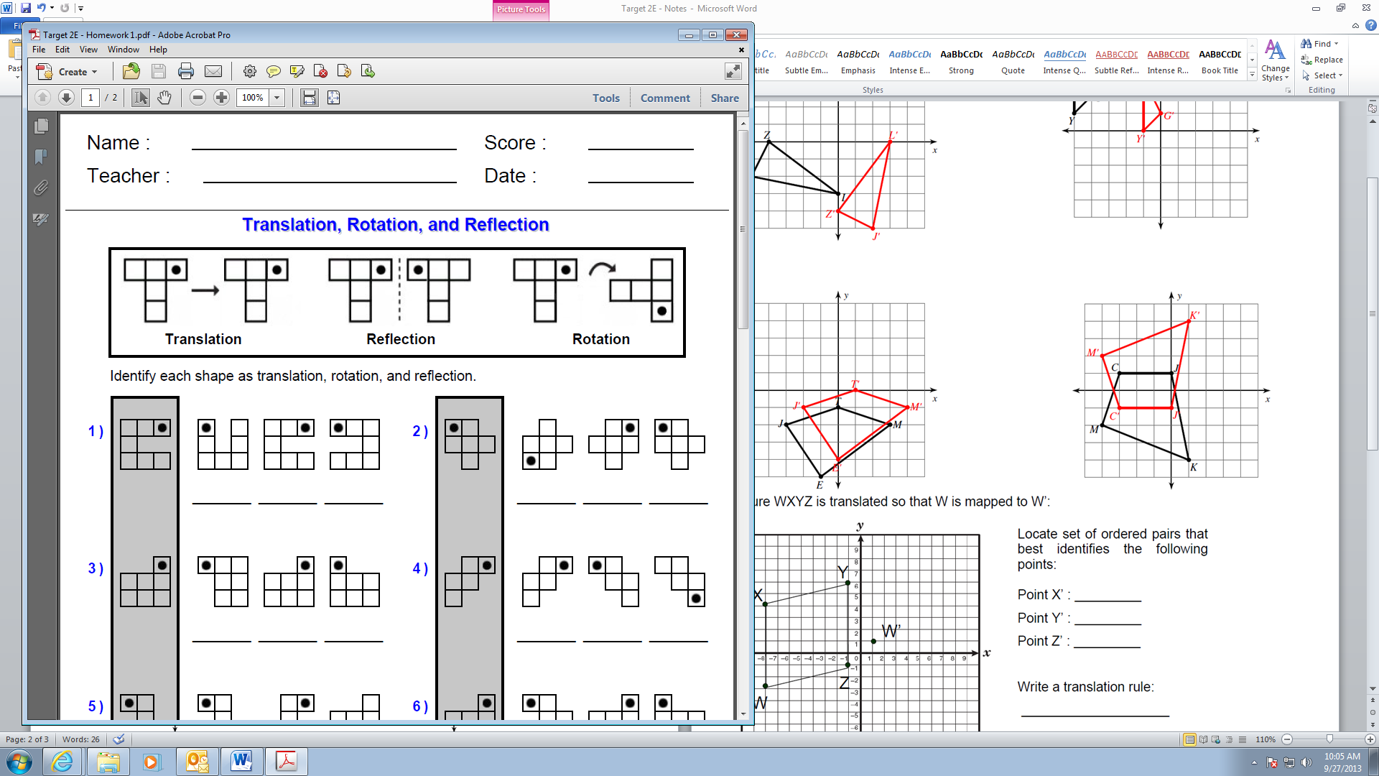**Rotation:**  a circular movement. There is a central point that stays fixed and everything else moves around it.

**Translation Practice**

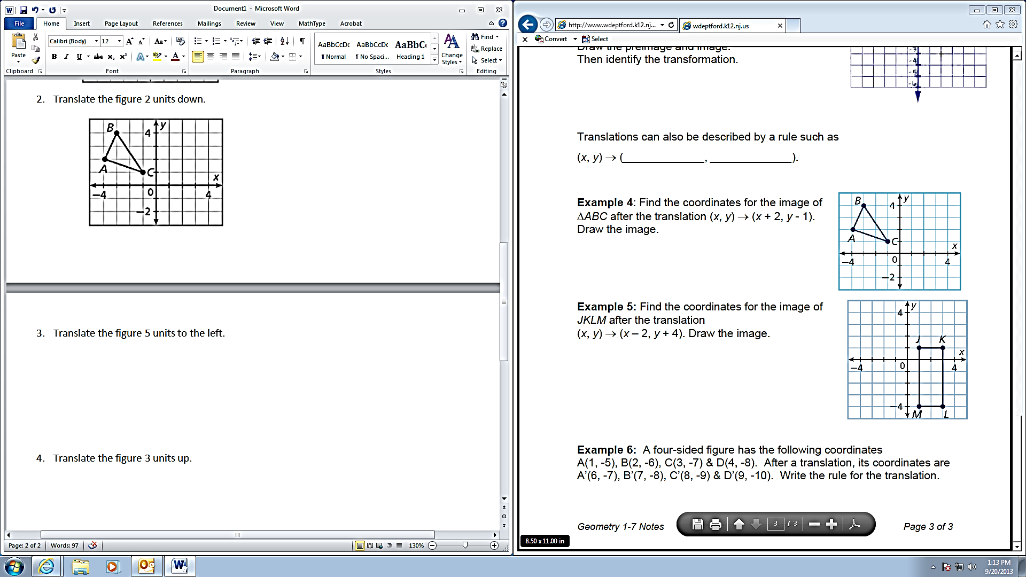Translate the figure 2 units to the right. Translate the figure 3 units up.

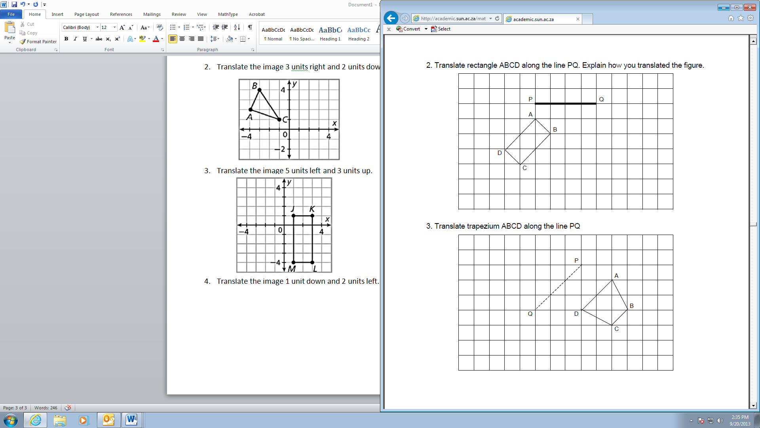Translate the figure 5 units to the left. Translate the figure 1 unit down and 3 units left.

**Reflection Practice**

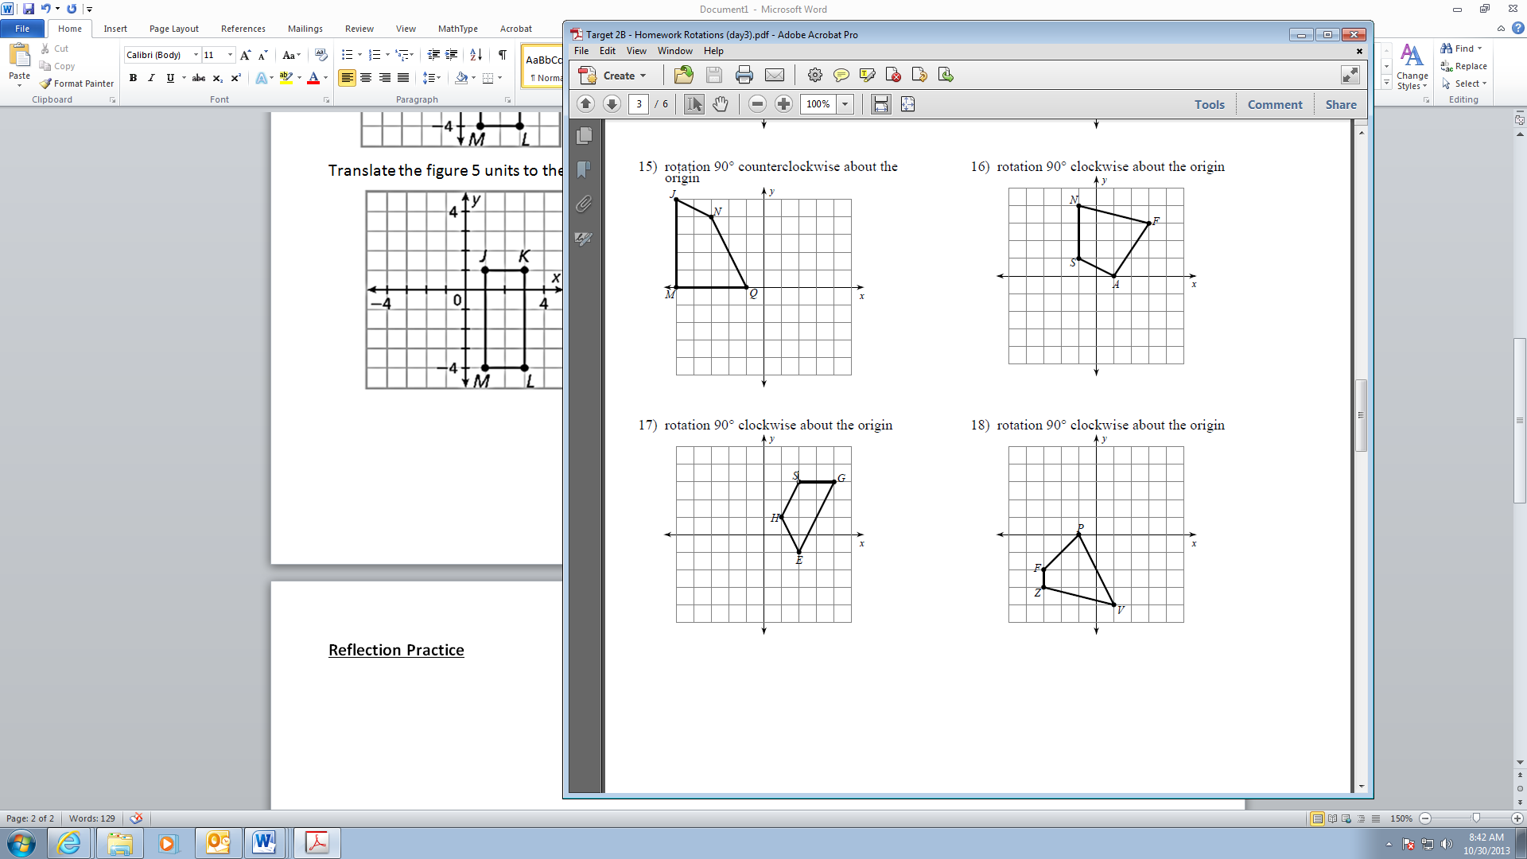Reflect the trapezoid over the y-axis. Reflect the trapezoid over the x-axis.

Glide reflection over the x=-1 line and left 4. Glide-reflection over y and 2 up.

**Rotation Practice**

Rotate 90° clockwise about the origin: (x, y) 🡪(y, -x)

Rotate 90° counterclockwise about the origin: (x, y) 🡪 (-y, x)

Rotate 180° about the origin: (x, y) 🡪 (-x, -y)

Rotate the trapezoid 90° clockwise about the origin. Rotate the trapezoid 180° about the origin.

**Identify Transformations**

Write a rule to describe each transformation.

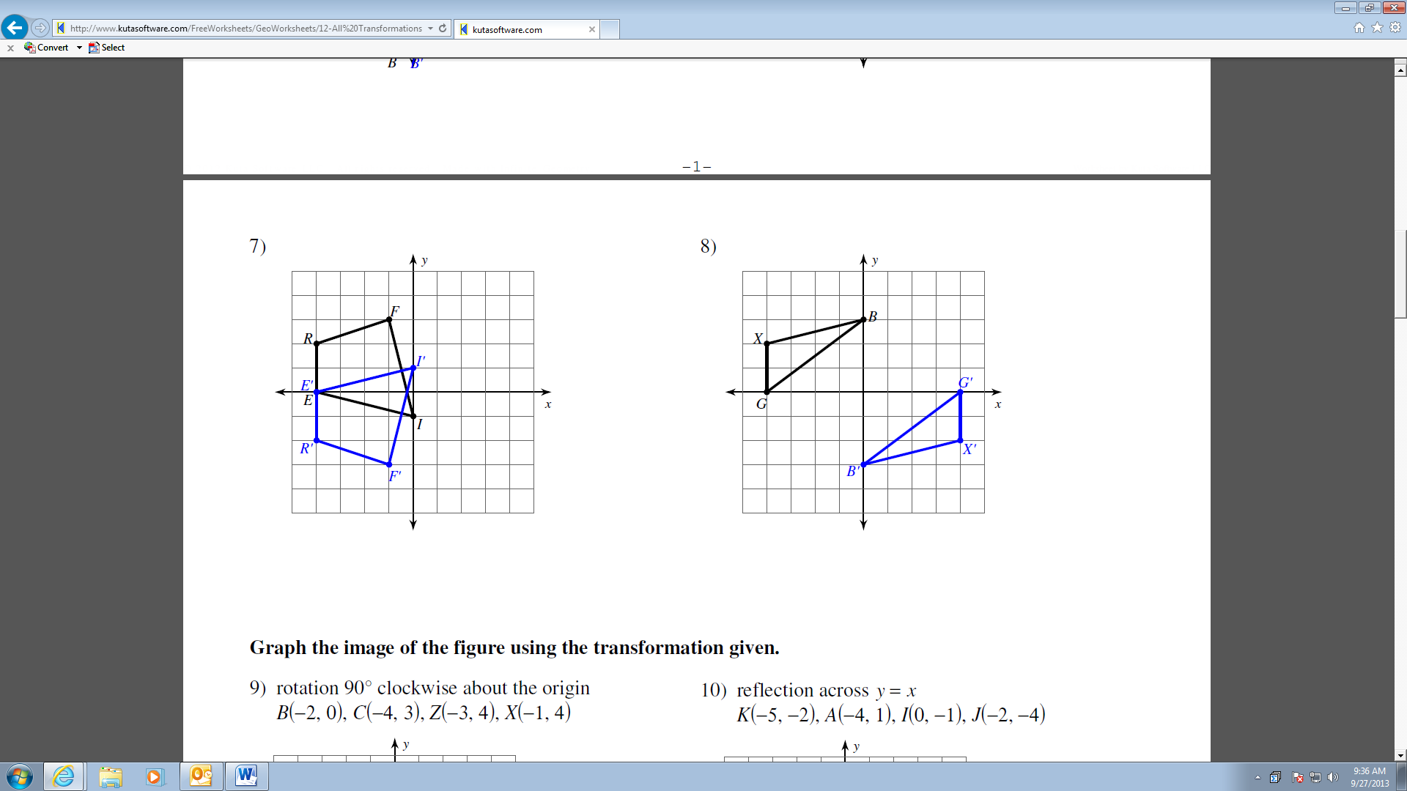

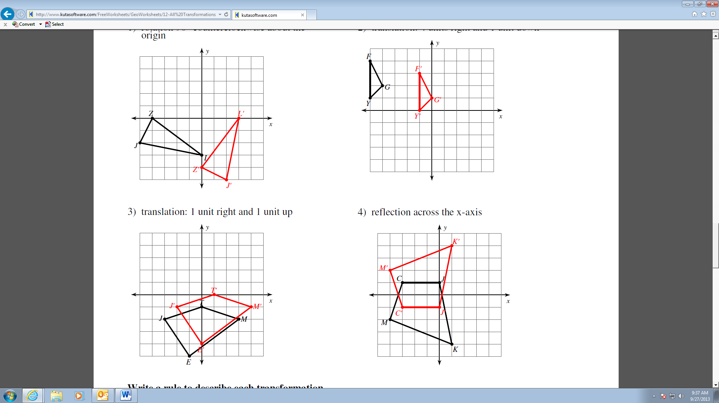

**Advanced Transformations**

Which of the following will map the rectangle onto itself? (circle all that apply)

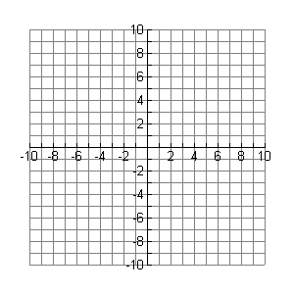

a) reflection over y = -5

b) reflection over x = -5

c) reflection over y-axis, followed by translation of left 6

d) reflection over x-axis, followed by translation of up 10

e) rotation of 180 degrees about the origin, followed by

translation of left 10 and up 10

List 3 different ways to successfully map the rectangle onto itself?



a)

b)

c)

List a series of 3 transformations that will map trapezoid ABCD onto the other trapezoid.



A

B

C

D

Step 1: ___________________________________

Step 2: ___________________________________

Step 3: ___________________________________

**Vocabulary**

**Symmetry:** A design has symmetry if you can move the entire design by either rotation, reflection, or translation, and the design appears unchanged.

**Line of Symmetry:** A polygon has line symmetry, or reflection symmetry, if you can fold it in half along a line so that the two halves match exactly. The folding line is called the line of symmetry.

**Examples**

How many lines of symmetry does each figure have? Draw all possible lines of symmetry.

**Practice**

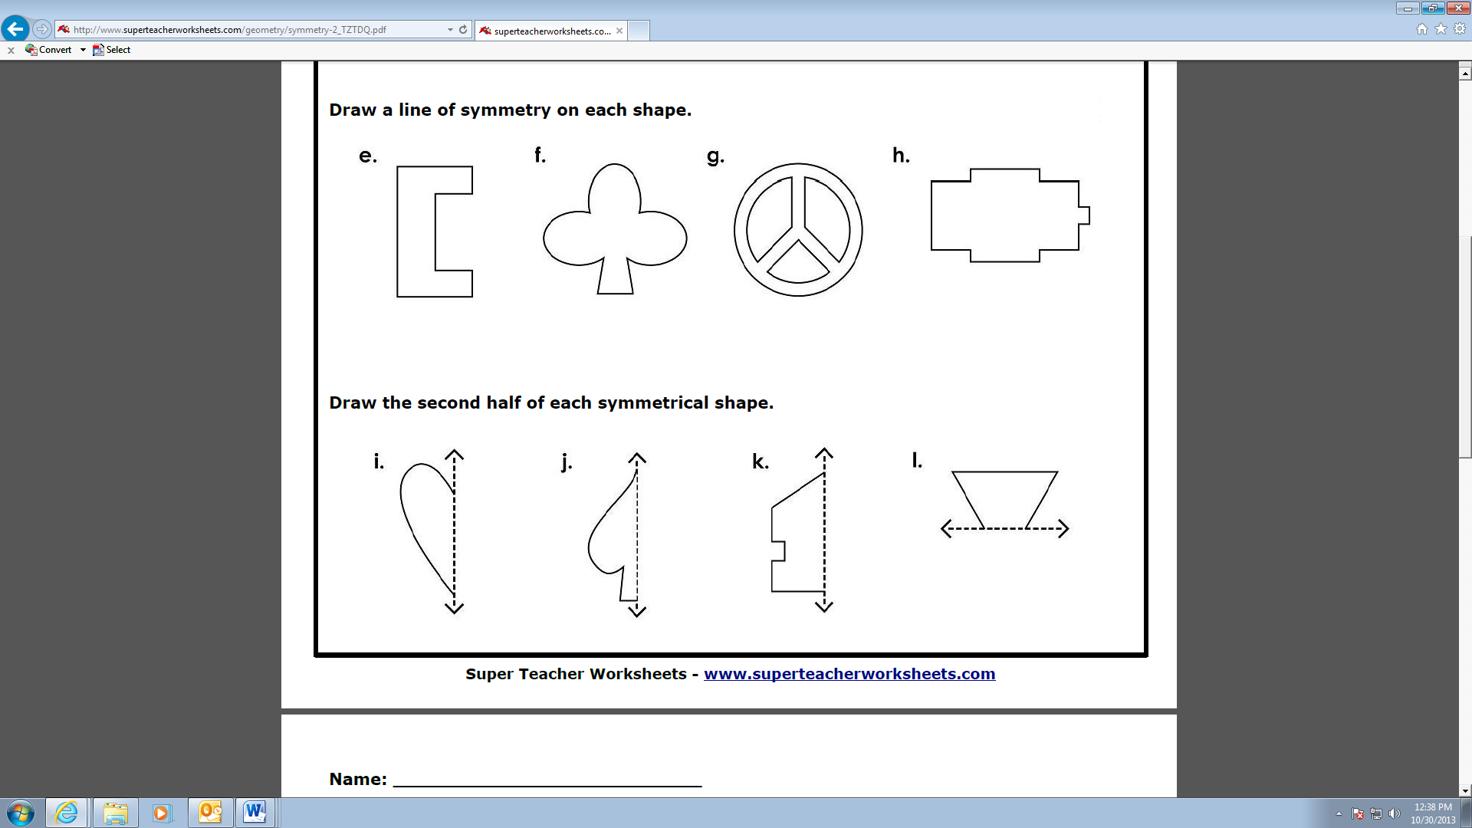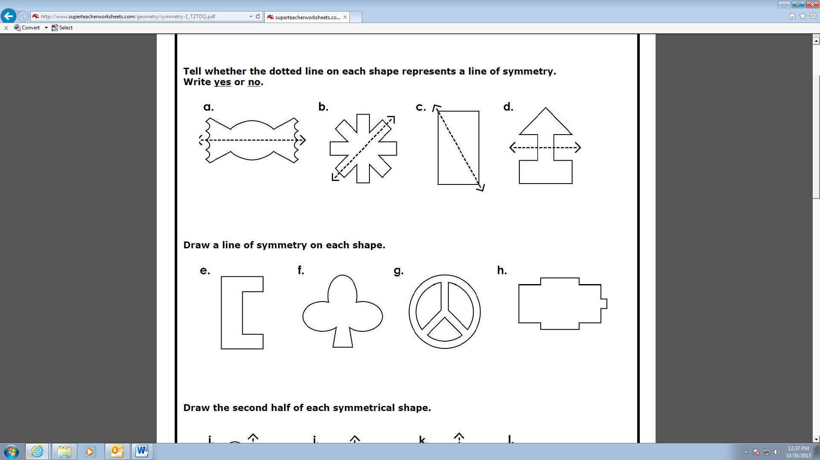

**More Practice**

Given the polygon ABDC and its image A’B’D’C’, draw the angle of rotation around point P needed to map the original onto its image. Give an estimate of the angle of rotation (be sure to specify clockwise or counterclockwise).

Do the same for ABDC and the image A’’B’’D’’C’’.

A’

B

A

B’

C’

C

D

B’’

D’’

D’

A’’

P

C’’

Draw the line of reflection that maps KLM onto K’L’M’. List the steps needed to find that line.

L

K

L’

M

M’

K’

A and B are equidistant from C and D. ∠C = 8m – 30, ∠D = 3m + 40, AC = 4m – 2 and DB = 9m + 1. What is the perimeter of ACBD?

C

A

B

D