SELECTED ANSWERS
Unit 3: Triangle Transformation & Proofs

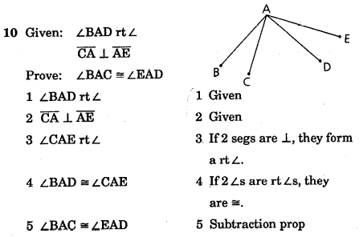
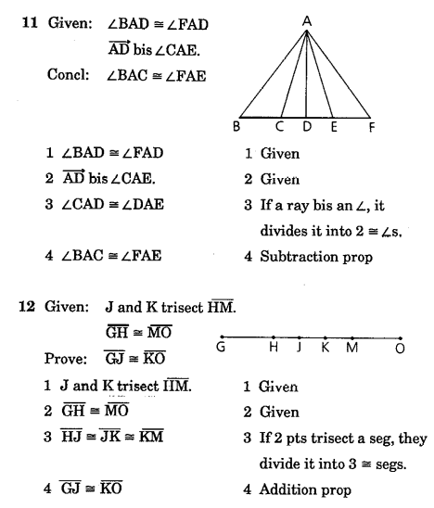
P24

P25

P26

P27

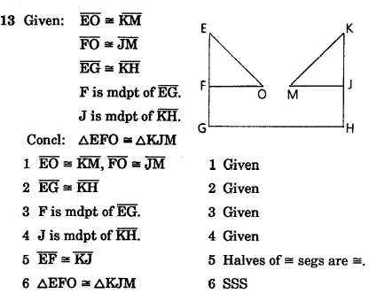

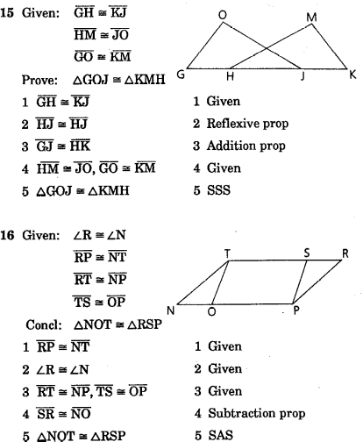

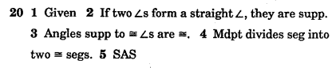

P28

At this point, you must be able to do 3, 4, 8, and 12 by yourself. If you can’t, seek my help. #3 is proved by SAS and #4 is proved by ASA (both are 4 steps). #8 and #12 are both proved by SAS and are 6 steps each.

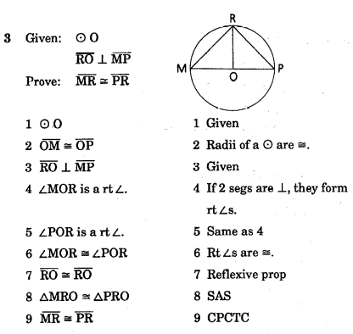
P29

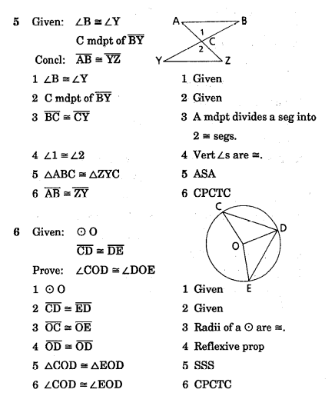

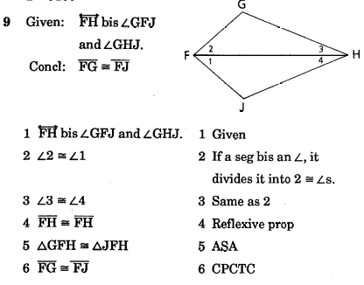

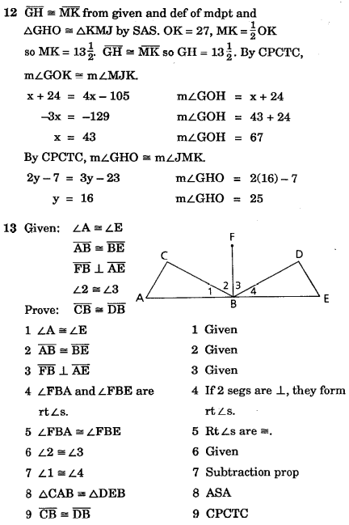

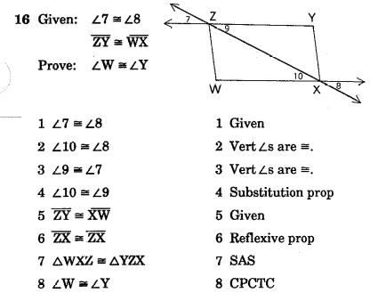

P30

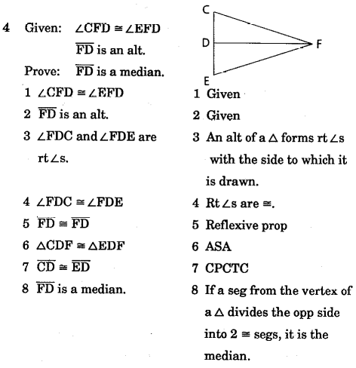

*This is not the end of the problem. Find x and then SW, WV, and ST.

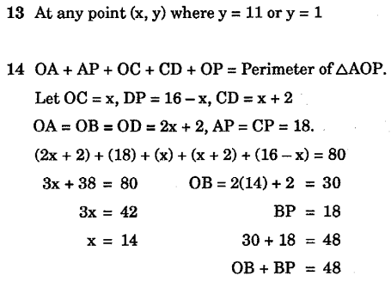

P31

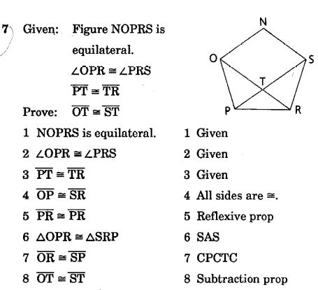
1 and 3 are simple proofs. If you can’t do them, seek my help. #1 is 4 steps and proved by SSS. #3 is also 4 steps and proved by ASA.

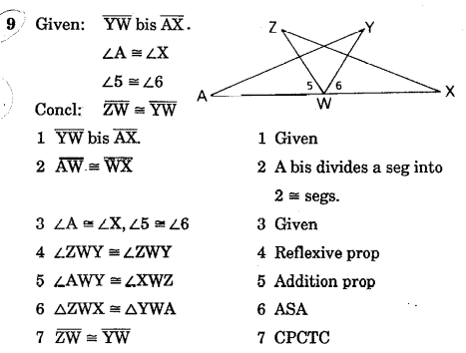

P32
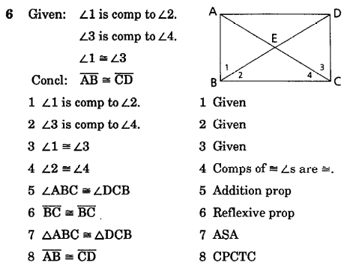

P33

1.

*This is not the end of the problem. Find x and then GE, GF, EF, and determine the type of triangle.

*This is not the end of the problem. Find x and then RS, ST, RT, and determine whether the triangle is equilateral.

P34

7. ∠B, ∠A, ∠C

19. You should be able to do this one. It’s 7 steps.

P35

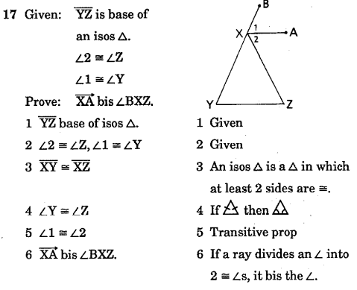

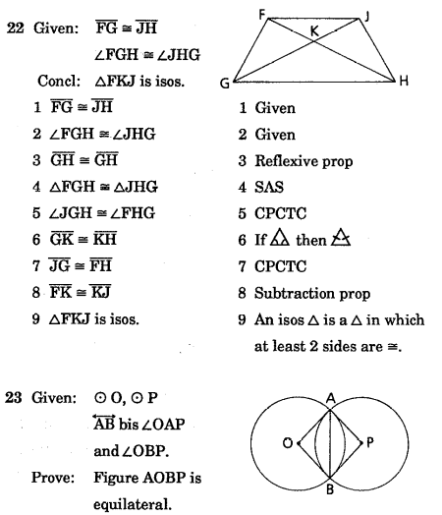

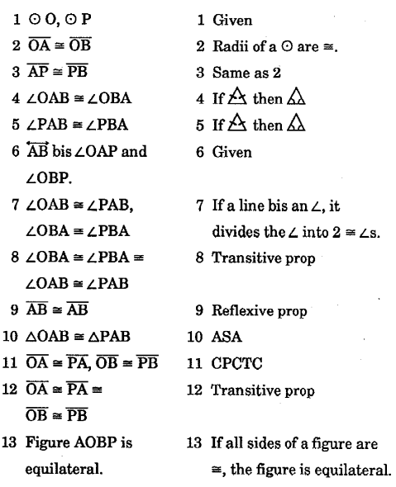

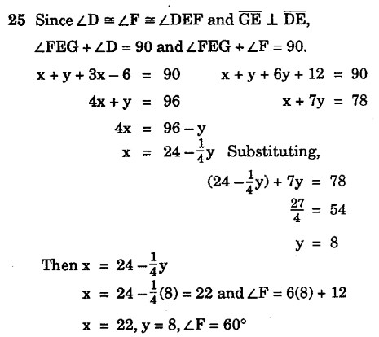

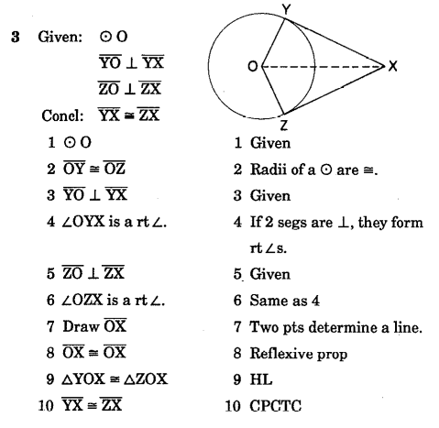
P36

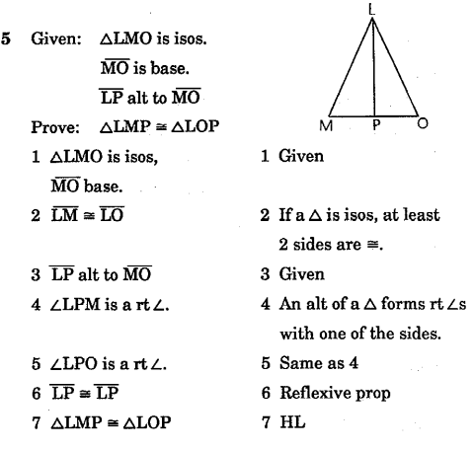

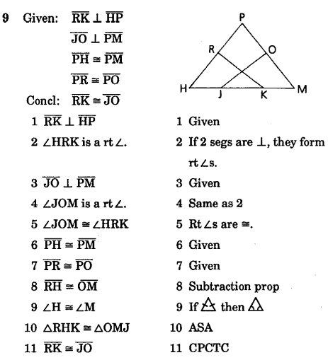

10. You can do this problem. You’re an expert. It’s 7 steps (triangles are congruent by SSS).

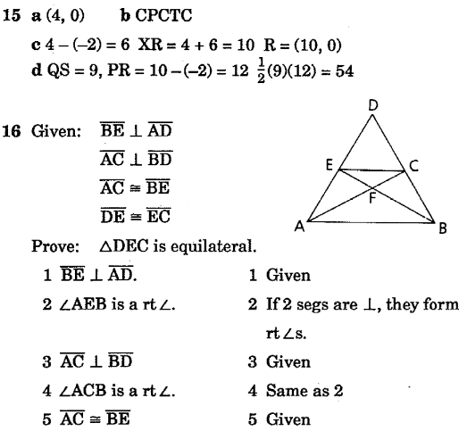

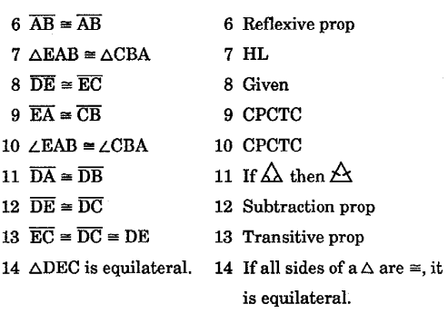

P38

You should now be able to complete this review with confidence given you worked diligently on all previous Ps

P37


